**Developer Diary**

***9th February 2018***

*17:00*

Started development with having a look through scripts that are inside ARKit unity plugin. No testing or changing code was done as of yet, just looking to through the scripts to get familiar with them and how they operate.

The goal for today was to start research and comparing more games which were implemented in AR, that use environment around player to work – how is UX designed in those games. VR games are to be considered too.

20:55

AR game titles have been looked at, where features and gameplay can be relevant to my project idea. Found out that at the moment there are not many titles that have relevant game mechanic, design that my project is focused on (world spawning around the player). Games looked at have minimalistic UI, have to figure out a clever way to minimalize UI in the game.

Would be helpful to look at some VR games, to find out how they indicate information around the player.

***10th February 2018***

*15:15*

Had some issues uploading files to GitHub, where progress from today was deleted and had to start from beginning. I have done what was recommended to me, creating a prototype which tests tracking of world even when the spawning location is not in camera view.

This was implemented using detecting horizontal plane, as it will work with any user input, however I thought of implementing some kind of board game into this game and having horizontal plane to have as a starting point sounds like a good idea.

Game involves having a cube in the spawn location which is initiated by the player, and then based on that location spawning two spheres, which have different locations. Player can easily view them and look at them without looking at the spawning location and it tracks very well. No issues.

There was a bit of learning required to get used to the code and how it would operate. After I got familiar with the code and how it operates, I didn’t run into any other issues.

*19:30*

There was an error with Developer Diary file, it was corrupted, had to re-download file that was backed up on GitHub.

Islands, which look like planets with very distinguishable colours for the time being, is implemented. First thoughts are that the planets are too close together, are a bit too big (size of 0.5 on all axes on Unity). For the initial implementation it is fine, will have to test it out and get feedback on the situation. Need to gather also feedback on the spawn location, if the plane is required or not – will depend on feedback and how player wants to play the game.

Created player character – a cylinder for initial implementation – where the top positions of each sphere are the locations that the player will be able to travel between. Not able to travel yet, but does spawn at the correct position.

There was a small challenge of getting the top of each sphere to be recognised as a spawn location, but it was overcome. The locations are stored in an array which can be easily accessed. At the moment, everything is being implemented in one document, which will change soon. It is done this way at the moment for testing purposes.

***11th February 2018***

*17:15*

Today focus on development was to get movement (tap on island to appear on that planet). This was challenging. Initially I tried to implement it using HitResult that is in ARKit plugin, however it didn’t work as after searching on the documentations, it appears that it only detects plains, and real-world objects and interactions, not what I was looking for.

My second approach was to use raycasts, which worked at the end, but there were problems to overcome along the way. Initial problem was getting 2D input to be transformed into the ray – it was quickly overcome by just double-checking code. One problem was detecting which planet it hit. As dependant on the planet hit, character will appear on that planet. Once I detected which planet was hit, the player appeared inside the planets – which isn’t visible – instead of the spawning locations.

It did work when I hard-coded the location as it had the same offset throughout every island, but I wanted it to work with the location points that I initialised every planet with. After further testing and changing things, I realised that it was the code that I saved the location points at that was a problem and the way that I accessed them. Now they do get written and read properly. There is an issue that the very planet (last in array) that is in the origin doesn’t get read properly, so have to investigate it.

*20:50*

The tap movement system works, for as long as the island/planet is not at the origin, it has offset of at least 2-axis from the spawn location. One solution that may overcome this issue is adding 0.1f to one axis (as it doesn’t work if position has the same 2-axis as the spawn location). Minor issue that can be worked around, and one case where it won’t work.

As the implementation is concerned at the moment, it is slow, as whenever I make any changes, I have to wait first for build to finish in unity, before building it on iPhone using Xcode which is a slow process, so testing is not as quick as I would have liked which affects the speed at which it is implemented.

The goal for today was achieved, where tapping does work to move the character. It has a bug that can be worked around as it is very minor condition which it works under.

***17th February 2018***

*14:15*

Started implementing Sprint Two today. Started with implementing testing buttons to have a prototype position where they might be. Full UI implementation will be done at later date. Today I started implementing Virus and first thing which I wanted to implement is virus showing up in game. This was done without many problems using Coroutines**.** When it was implemented there were some issues, but they were issues setting up (assigning materials again since I renamed the variable), which were easily fixed. Once they were fixed, the game plays like expected and I set it up to initially wait 90 seconds before virus shows up but it can be easily changed.

At the moment, the whole project is being implemented on one single script. When everything is working and being implemented – thinking at the end of Sprint Three – then I will split it up into separate scripts to be neat and easier to manage the code.

***18th February 2018***

*13:55*

Today I am focusing on visualisation of virus and the spread of the virus. I increased the spawning planet size to 10 – for better testing – and made the planets smaller (to 0.2f), will get feedback in testing to see if it is better to have the planets bigger or smaller.

I managed to implement spreading to the nearby planets without any troubles. I used mathematical Pythagoras equation to find the closest planet for which it will be infected. Once infected, at the moment it just changes colours and the planet tag changes from “*Planet*” to “*Infected*”, this information is used to find out if the planet is to be infected or if it’s already infected.

By testing it out, the spread of planets at the moment doesn’t look great and some planets are too close to each other, so once everything is implemented together, the plan of where each planet will be located – with the agreed size – will be implemented.

When was looking through the code, I found little bug that I fixed, where initially when I was calculating distance, I was only taking account x, y axis and y axis was taken into the equation twice, fixed it by changing one y axis to z axis.

*15:40*

For testing purposes, I reduced the time which takes for infection to start from 90.0f seconds to 20.0f, and also the time which it takes to spread is quicker than it will be implemented in the final product – 5.0f is set to at the moment.

The alert system is implemented – in portrait mode, have to get feedback which orientation the game should be implemented – when the infection begins. It starts 5.0f seconds before the actual infection appears on the planets with outline and text appearing on the screen. It looks ugly. But for testing purposes and gaining feedback, I think it will work. It will be changed later to look more pleasing.

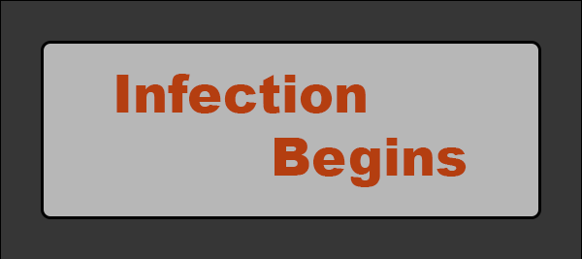

***19th February 2018***

*19:25*

Today was focused on creating a connection between the planets. It had a lot of problems along the way, in a form of first not displaying the prefab of cylinder at all. I tried to implement each connection inside an array, but for current implementation it wasn’t implemented. Goal was to have a connection going from one planet to another, however at the moment all connections go from one – the beginning planet.

The prefab was initially along the y-axis, however later during testing it didn’t display in correct direction, so the mesh was rotated 90 degrees in x-axis. This displayed the mesh in correct direction in testing, but not long enough which has to be adjusted in the code.

It was implemented using localScale, with prefab of cylinder being created of scale 0.02f in all axes. Using transform, I calculated the distance between the two points (the two planets), and calculated the midpoint from which the prefab was displayed. Tried to calculate how to stretch it along the correct path, initially trying to work in y-axis, but after many tries and testing, it wasn’t working properly, followed by x-axis with the similar result. After testing out z-axis at the end, it worked, however the value has to be multiplied by 50.0f otherwise it is not the correct size. I am not sure to that value – with the distance being calculated before – but it has to be implemented and works at the moment.

All points go off one planet at the moment, which has to be changed to the links coming off correct planets.

***20th February 2018***

*12:15*

Fixed situation where the link points only go off one planet. Now the links go off the closest planets – just as it should be implemented in the first place. Also, saved the connections – links – in an array for easy access at later time if needed, compared to just creating them when needed and not being able to access them again.

The information of start and end planet (which planets are connected to each-other) is stored in dictionary, key being the start planet and list of ints is created as the values for all the connections coming off that planet. The link is stored in an array, where at the moment I can’t think of a solution to link the array and the dictionary together. In the meantime, whenever I need to access the link, I will look at start and end planet and based on the location of the planets and the link position I will figure out which link it is relating to.

Fixed a small bug, where the player starting position wasn’t saved until the first move was made – the initial position of player wasn’t saved. It is solved now and planet location is saved initially when game is loaded.

*13:20*

Dictionary was removed due to not working as intended. It was breaking the game, so for now dictionary is deleted, but the initial array for the links is still in place. By the use of planet locations, I will identify which link players are relating to.

After getting some feedback on the pause menu location – the feedback was to keep it on the bottom right (in portrait mode) for easy access and doesn’t get in a way. Also, at the moment the character is able to go around every planet – what I want to implement is the limitation that player will only be able to travel around closest planets – not able to travel to any planet that they want.

*16:35*

Implemented Pause menu where it has “Main Menu”, “Restart”, “Back” buttons, where main menu is yet to be implemented. It stops the time when the pause is in place. Also, have added command that never dims or puts the phone to sleep when the application is open.

Also added GameOver screen, which occurs once the player is on the infected planet. Surprisingly there were troubles to make it work, not sure what the problems were, but they seem to be simple like not referencing or calling the function properly and had to change locations when the GameOver function is called. I had it to scan every frame to see if the planet that the player is on infected or not and based on that affect the result, but it didn’t always show the correct results, when the infection spread towards the planet that character was on already, the GameOver screen wasn’t triggered. Therefore, I added if statement in the spread function which checks that if the player position is the same as the spread position then GameOver screen is triggered.

Also, made Game Manager game object which holds the scripts which control the UI and states of the game.

Everything implemented is very basic with simplistic graphics and functionality, the idea being to improve it once everything is implemented and working as intended.

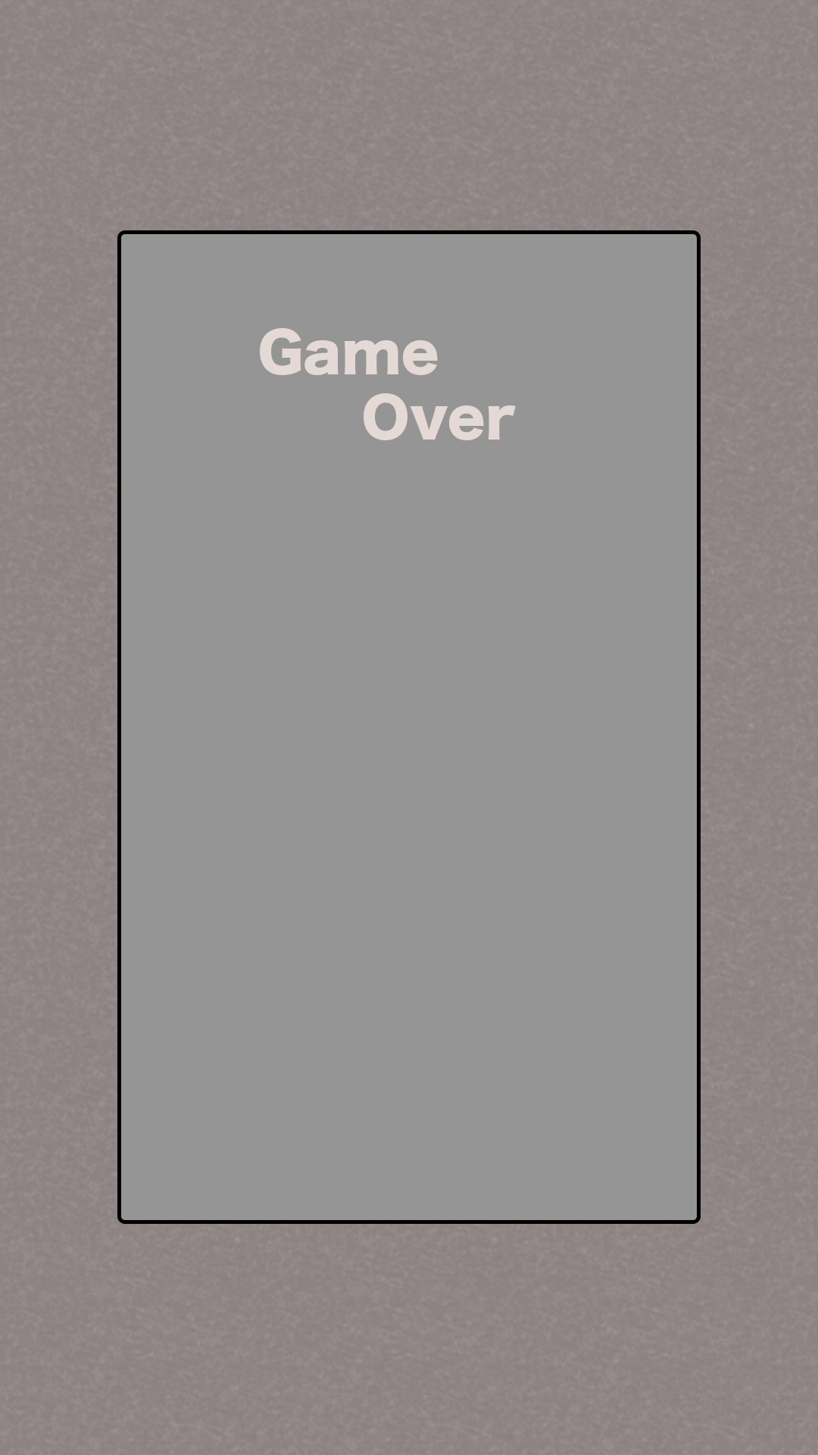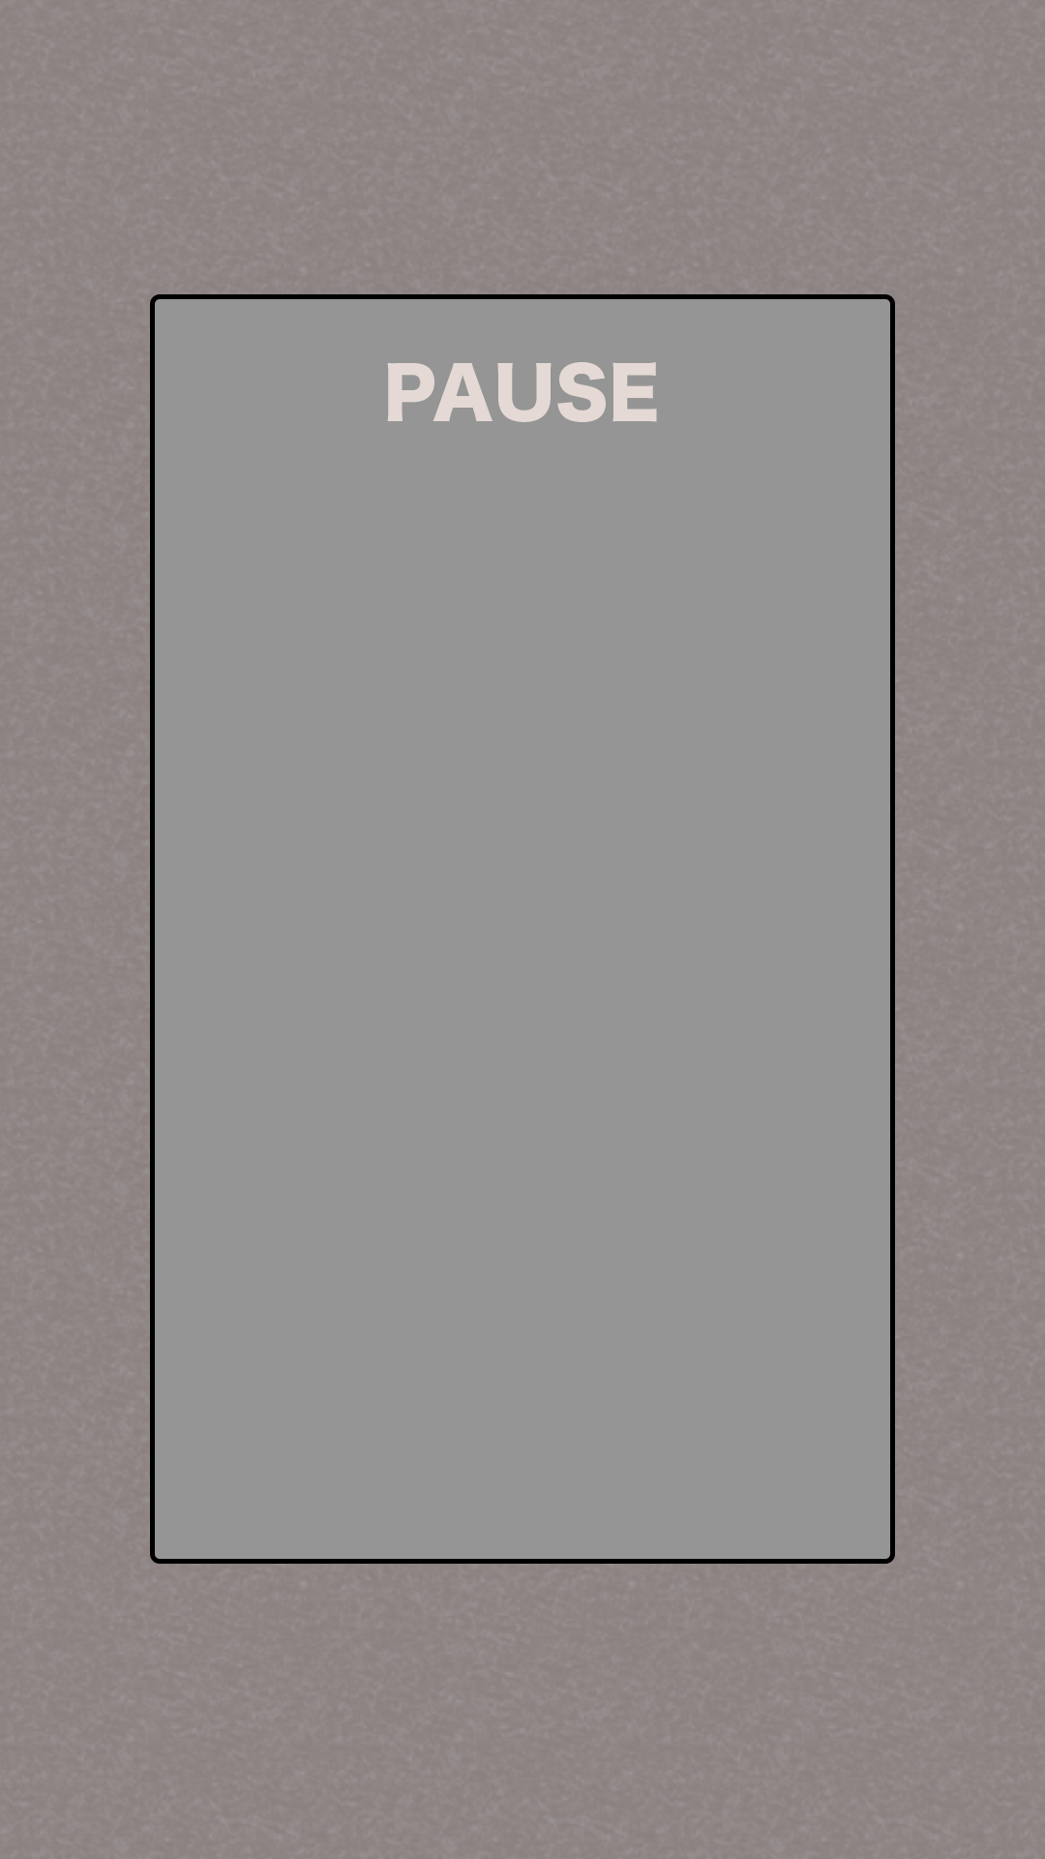

***26th February 2018***

*16:00*

Did testing of 8 people testing the orientation of the game, the result being landscape orientation. The orientation of the game was changed to landscape. I used 3D TextMesh available in Unity to display text on menus which will be displayed next to the planet. The planet has 4 locations (front, left, right, back) where the menu can be displayed in. At the moment, the menu only shows up on the left side of the planet every time. The menu has one big intractable button – that is not active at the moment but will have point of action once programmed that will do an action. Actions available are move, pickup ingredients, place mix solution on the planets to cure the infection.

No issues at implementation at the moment, however it takes a while to think of how to implement it logically. Instantiating the prefab for menu to be displayed at the right location. Looking to have the right rotation to be in the direction of the camera. Meshes and colours are basic for the time being to minimalize time spend on implementation and easier to make changes based on the feedback.

*17:40*

In progress on implementing which menu shows up on the menu. There are complications in the form of menu disappearing without displaying anything. Not sure the reason for that. Created separate variables to track the input. Have different functions to be called at times to track inputs and when the action button is pressed.

*20:20*

Issues occurred when trying to implement pressing the button, where the game would not load (the game world that is), unless the game is restarted through the pause button. Another issue was that the menu was not showing, or it wasn’t counting the press correctly, either blinking or just not appearing, or appearing without being active. Also, another issue being the presses were not registered correctly, as moving the finger around would initiate the different functions. Currently, the game is implemented with touch.phrase == TouchPhrase.Began to track the press, and it does work as intended when it comes to presses, however it does not turn off the menu once the planet is pressed again. It only works initially when the planet is pressed.

***3rd March 2018***

*15:20*

Had an issue when it comes to turn turning off the planet menu as it did not work when was clicking planet again. Due to this, I decided to implement a red exit button which turns off the menu, and once it was implemented it worked as intended without any problems. Using raycasts to detect when the exit button was hit as it is in the tag on its own called “Exit”.

Thinking of 3 win conditions (done by doing different combinations of ingredients gathered). Bomb that explodes and heals the planets / Healthy link spread / Health solution place on planet.

***4th March 2018***

*14:35*

Implemented all states: Move, Solution, Collect, Collected buttons, however it does not show in correct manner, there are bugs as the points/how many ingredients there is available on the planet is not deducted. Have to fix those bugs and have working version before continuing implementation.

*15:55*

Implemented the text showing the number of ingredients available on the planet. Once it is collected, the menu disappears. Now everything is showing as it should, once the ingredients hit number 10, the player will be able to place the solution on the planet, and at the moment it send the player automatically into the winning screen. This will be changed to match the winning conditions, where player plays the game according to the mix combination.

There were a little trouble with displaying the ingredients on the menu plate. First I tried to search for the object by .GetComponent<TextMesh>().text, however it did not display any results, therefore I changed my strategy to first .Find(“Text”) (that’s how the object is called in the prefab), followed by .GetComponent<TextMesh>().text. That seems to work. Then I was working on displaying text, where first I used string.Format(args), however it did not show any results, it ended with not showing anything. Then I tried just entering “string” + arg way, however it did not work either. Reasoning for nnot working is unknown to me, however, when I tried to create a separate string variable and use string.Concat(args) it worked perfectly.

Once this was implemented, when the player clicked the collect button, the whole game would freeze, which was unknown error. However, I think it was as in collect function, I called recursive function for MenuAction which displayed correct text and menu options available for the planet. I passed the argument of player planet position, which I assume cause some sort of recursive call just freezing the game. I fixed it by not calling the MenuAction function, and once the ingredients were collected I changed so the menu just disappears.

That is the reason for menu disappearing once the ingredients were collected, not intended solution as I wanted the text to just change, however it does work as it is. The player just has to click on planet again to view possible options. It is fine as for testing the functionality, this solution may be changed at later date.

*16:40*

Implemented a split choice when the player has enough ingredients for solution, and if there are more ingredients available on the planet. Changed the ingredients required to place the solution to 5, previously being 10, for easier testing. Whole game will need to be balanced while everything is implemented and working. Now player can choose what to do. Next thing to implement is the inventory system, which initially will be implemented with the pause screen.

***5th March 2018***

*12:45*

Implemented the basics for inventory system, where it splits the screen with the pause menu, only showing the basics of the inventory for now. It shows how many ingredients the player collected, with an option in inventory to create new solutions to win the game. The menu is moved to the side, which I think takes better advantage of the whole screen, while at the same time it has less interact-able buttons in the game screen, showing more of the 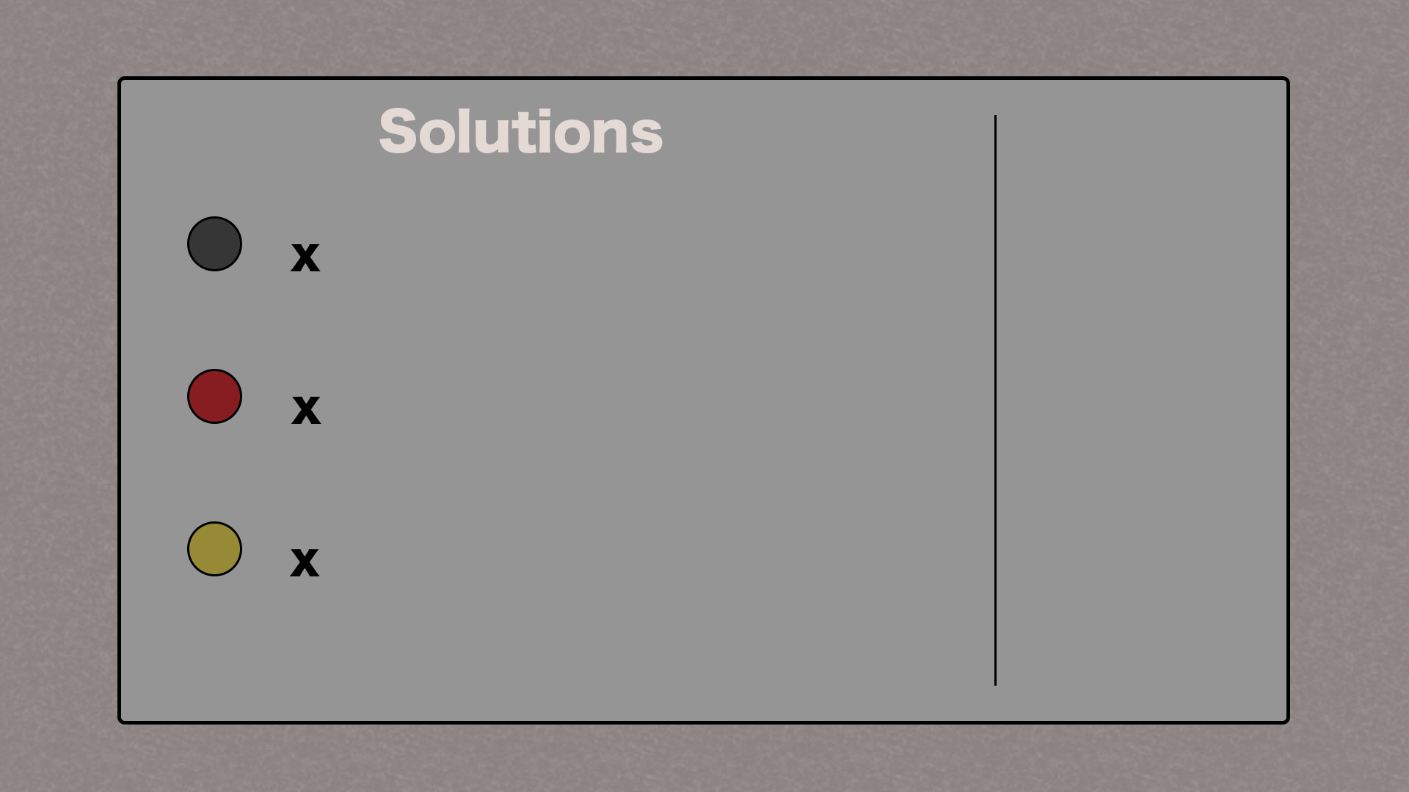screen for the gameplay.

The numbers get updated as the player pickups the ingredients, it is reflected in the numbers on the pause/inventory screen.

Plan to implement next is the solution choice in the planet menu, and the creation of solutions when the ingredient number is of certain number and the solutions having different effect on the game.

***8th March 2018***

*11:40*

Was implementing the two solutions for the game, including the UI in the menu, the code to count the different solutions, namely “Health Link” and “Big Bomb”. The coding was implemented and there were no issues, however when I was implementing the UI, for some reason the UI did not want to appear, the solution button stopped working. It happened after I have changed the tag name for the solution button. This problem was fixed once I reloaded the project in Unity. Now everything is working as intended.

***9th March 2018***

*21:00*

Created the prefabs and everything ready to have implemented for two different winning solutions for the game. The link solution was copied and applied in similar way that the spread of the infection was implemented, with different green texture. The big bomb is yet to be implemented but will have a semi-transparent texture on a bigger sphere and the planets touched by the sphere will be ‘healthy’.

The linking is not working properly, as when the link goes over the infected planet, it does not stop the infection, i.e. it’s not working properly and it gets stuck. No other progress is made. Don’t know why that happens, more testing will be done later to figure out the cause of that.

***10th March 2018***

*10:55*

Today goal is to finish implementing the two solutions for the game. Fixing some bugs with linking system, namely where the infection could spawn on the healthy planet. Now I have added additional check to see if the planet that is being infected is healthy or not with the tag check, as the planets have tags to see if they are healthy/normal/infected. Having those extra checks fixes this issue. Another change that was implemented is that there is a wait now when the link is put down so the first link doesn’t occur immediately. Additionally, I added a constrain that the health link can only occur 3 times so the game won’t end when the link is put down and it makes player to keep playing.

*12:00*

Implemented the bomb mechanic, where it has a radius and anything within this radius becomes healthy. I have implemented it by taking a collider of a bomb prefab and checking the bounds.interection(planet collider.bounds). If it is within those bounds then it is within the bomb range. Once it was implemented, it works as intended. Increased the blast radius, originally from 0.5, then 1.0, and now to 2.0 for it to be more impactful. Then reduced it back to 1.5, as 2.0 was too big and was the size of almost whole game world.

One thing I will have to change, or add, is the tag for bomb explosion, as it can be infected by the virus again. Also, looking to implement the instruction screen at the beginning when the game is launched and also the ingredients recovery, so after certain time the planets have extra ingredients.

Will implement the winning condition (when infection reaches = 0), and also a possibility of collecting ingredients once the infection started.

*15:20*

Implemented the different tag for planet, which represents healthy planet, but it can still be infected. Implemented the ingredients recovery – at the moment every 10 seconds the planets ingredients is increased by 1. Also, the menu system is now displayed the closest position to the player, has to be refreshed, the planet has to be clicked again. It will rotate to the camera too. I had to change the prefab to be face in the opposite direction to be visible in the game world correctly. But it does work as intended so far.

Next thing to implement will be to have instructions at the beginning of the game, and also increase the time in game when everything happens before doing public testing.

***12th March 2018***

*11:20*

Implemented the instruction for testing session, saying what to achieve in the game and what do spheres mean in the inventory/pause screen. Also increased the number of ingredients required for solution two (the link solution) to 10, from 5 initially, as it is a permanent effect and I find it to be fairer. Will see how it will impact the feedback. Another thing that was changed for the game test is that now the infection alert will popup 10 seconds in the game now, instead of 15 which was before, and the spread now occurs every 8 seconds instead of 5.

*16:05*

There were few bugs in the implementation, mainly the player couldn’t click on the planet when it was green (healthy) and there was no win condition – the winning screen didn’t appear. Both of which were addressed and the bugs were fixed. Planet click was fixed by adding the healthy planet tags to the click recognition code where menu shows up, and the winning screen was fixed by moving the condition from Coroutines function to update function.

The number of planets is also being implemented up to 20 (from originally 10), to increase the game time. No issues were encountered when fixing bugs or increasing number of planets. Except of making crazy-stupid mistakes (typos) and forgetting to change the number of objects (to take into the account the new planets too), also pasting the part of code twice, overwriting and breaking the game. This caused the game not to behave as intended, not changing materials and such.

The game freezes at some occasions, think it might be due to not able to find new planets or something to do. Looking into solution now.

*17:00*

Changed the prefab for the bomb back to 2.0f to have bigger impact on the game as I rearranged the planets. Now I check in the game if there is a planet to spread on to, if not then the virus Coroutines is stopped.

***16th March 2018***

*10:25*

Started implementation of fixing/changing the game to be more enjoyable. Starting from scratch and will use the code whenever I can from my unsuccessful prototype. I will change the menus, by deleting them, as they are not required. Add music for sound effects and better experience. Have models from assets store to use for better visuals. Have introductory sequence at the beginning of the game, instead of written instructions to introduce player to the game. Infected planet will have a projectile shooting at other planets which can be interfered.

Found the planet assets that I will use for the game. Have 7 planets (6 useable for my game) which can be presented and used for the game. Have created and modified the scale (range between 0.025 to 0.05 to have bigger range of different planets, and have the colours/shaders attached to them working for the game.

*12:55*

Implementing code for starting sequence, where planet moves from bottom of the spawning point up to its position, however, it does now display anything. After investigating the project, I figured out that I have forgot to put the prefabs and the array list objects in (the materials and the planets prefab). Testing it if it will display correctly or not, if it doesn’t then I will test without the transition, to see if the planet will display at all. I implement the game currently in different scripts to make it easier to change at later date and easier to read. Looks nicer too.

*13:10*

After testing the spawning of planets, it does not display anything (apart of the spawning location). Investigating cause now.

*13:30*

Only displaying one planet, I put all spawning in one script, but it only spawns one initial planet before stop working (had to not use the shaders provided with the planets as it didn’t work when implemented in the game).

*16:20*

Tried to find out what was the fault with the code written in the Spawn script. I have copied what was previously in the WorldSpawn script and the WorldSpawn script was working fine, and I compared it next to eachother and both being identical (apart of script name). It was just phrased differently to be clearer and tidy. However, it did not work and was only ever displaying 1 planet. Tried restarting – didn’t work

After trying to figure it out, I have copied the WorldSpawn script again, and deleted all the unnecessary data from the script (pretty much everything apart from the PlanetsSpawn function) and tested if it will work fine. Surprisingly, it did display the data and information correctly with planets displaying correctly. So, based on that code, I will modify it and work on it to complete my task given, still uncertain why the initial Spawn script wasn’t working.

*16:55*

Implemented the random planet to spawn at the locations, instead of the same planet as it was done at the beginning. The planets after testing do seem like they are too close together, especially since those prefab planets are bigger than the ones previously used, and the distance apart will be increased once everything else will be implemented.

I have disabled the particles. I have also disabled the blue square showing up as I believe it affects the experience. The player has to scan the are a bit by moving the camera around and then the player will be able to spawn the world by clicking somewhere.

*22:00*

Manage to implement the transition the moves from the spawning position up to the desired planet position, with scaling as it goes up (with Time.deltaTime). There were difficulties, as I was testing and doing more implementation and trying out new ways to implement (having a variable of Spawn to access the transform location of planet, or different functions, or have .GetComponent<Transform>() which none work). Had to have only position to go across in the public function in the spawned script, that’s the only way that it works when I implement the transitions.

Ended up having a Vector3 as a position to go across to script which I store variable for the planet original position and then I move it from the spawned location up to the planet location with increments of Time.deltaTime. Scale was easier to implement once the transition was done, I have taken the one float from the localScale of the planet (knowing that x, y, and z have the same float variable) and I stored it in a variable which then I had another variable to make it smaller, and just like the transition, I increment the scale with Time.deltaTime (without any multipliers, as it seems to give the smoothest transitions).

I have created a Get and Set functions (for Scale and Position (transition)) in the Spawn script, as the variables are private and that’s one way of accessing them from the other scripts. I access them, and modify, in the GameManager script. Looking to make a popup with description next, followed by an infection introduction, followed by the infection spread, then ingredients, then world spawn. The description text might be left towards the end. The sound will be implemented at the end too.

*22:35*

Based on the already created transition, I implemented another planet showing up with the planet changing material to red (to symbolize infection). Thing that has to be still implemented is the instructions, and the shooting spread of infection, ingredients in the available planets, and the sound.

***17th March 2018***

*12:00*

Found a space ship and platform which will be used in the game for the spawning location and the infection spread missile. Implementing the infection spread now. The spawning location is at 0.2f scale on all axis, while the projectile is at 0.04f scale on all axis.

*13:30*

Manage to make the projectile go from planet to another planet, although originally, I wanted to have the transition code to be in the projectile prefab, but it wouldn’t work for some reason (nothing shows up), and some variables had to be assigned were unassigned if the object wasn’t in the scene.

I have overcome the problem of instantiating the prefab in the Spawn script when the planets are being spawned, and setting its active state to false and calling all functions and calculations in the GameManager script. The projectile script will have a script Destroy, which will take affect when player clicks on the prefab. Also, once the projectile was working, it was facing incorrect way, so I rotated the prefab to -90 degrees in the y-axis which solved the problem.

Also, while doing testing, I noticed that the prefab is still a bit too big in proportion to other objects in the game, therefore the object scale will be reduced to 0.02f.

*14:05*

Implemented the path, which makes up of little spheres, which indicate the trajectory of the missile. It is implemented using GameObject array. No issues encountered implementing this.

Made the planets move quicker – to 5.0f – but it is too quick, so it will go back to traditional 1.0f.

*16:30*

Made the path to appear one by one, and now the planet changes colour to warning colour when planet is being infected.

*17:30*

Was implementing the hit collider, when realised it didn’t work on the projectile, and then I figured out that it is because the prefab doesn’t have a collider, the problem was solved once I added the collider to the prefab.

*18:15*

Implemented a reset point if the projectile hits the planet at tutorial session. Limited the click range from 10.0f to 5.0f to encourage player to move around. When the projectile reaches about ¼ distance left to the planet to infect, the Time.timeScale is reduced to 0.1f for information popup and time for player to adjust.

*18:35*

Hit range reduced to 1.0f, as it feels like you can touch close to you objects but not far away objects. The distance at which the planet becomes infected is now reduced, so it gets infected quicker (once the projectiles disappear in the planet).

---- *19:15 -----*

Thinking how to implement the ingredients for the planets. Decided that there will be three solutions/options to choose from being: Slow Time, Bomb, Shield. Each one of those will be available on different planets, floating around the planet that will be available to be picked up when clicked on the planet. Thinking of those solutions to float in orbit around the chosen planet.

The UI being the pause (top right), planet status (healthy/infected in top left), abilities located in bottom right (with availability ring around each ability).

Things that still need to be done:

> Graphical assets (introductory information, abilities, ability indicators, planet statuses, pause)

Graphics taken from Flaticon.com (free to use, have to state the author). Have ability icons from this website.

> Sound (background music, sound effects when projectile gets shot, sound effect when planet gets infected, when planet gets healed)

Chipmunk sound from soundbible.com (talking sounds, searched: inaudible talking sound effect) Also sounds for infection bg music (water drops) and shot fired (shotgun). Attribution 3.0 licence.

BG music has text where it’s from

> Win/Lose screens/conditions

> Ability coding and effects

***18th March 2018***

*12:40*

Implementing the sound, and as I have never implemented the sound in the game firstly I was trying to figure out everything and how it would work. After having just one audio listener (on camera), I added audio source to the camera, as a background music. Firstly, it didn’t work, and after further testing I realised that the device has to be unmuted for it to work, and after that it worked fine. But in testing I come to conclusion that it works better as a planet music instead of background music.

The music for infected planet is also implemented, having issues by script on planet trying to activate it, therefore it is activated by taking AudioSource component when the planet becomes infected and it plays. However, I find the radius is too far and has to be reduced (currently maximum is 0.4).

*12:50*

Realised when looking at variables, that the settings were set for 2D sound, and had to be changed to 3D for fading to take effect. Now it works as planned. After testing, the range got increased (dependant from planet, as planets are different sizes). Before all planets had 0.4 for maximum distance, but due to size I changed it to be between 0.2 to 0.4. Now the distance will increase to get better experience and hear the sound. Increased now between 0.65 to 0.8.

AudioMixers are used to mainly control the volume of the sounds.

*13:15*

Thinking I will increase the sound of infected planet to a larger area. The sound for shooting was also implemented, and thinking the sound for destroy has to be added too. For now it is okay, and have to complete other tasks.

*14:50*

Now that the sound is in place, I started to work on infection spread. I rearranged the code a bit so it would be easier to skip tutorial if player wants to just start a game. I looked at the code from the original prototype to base the foundations on when it comes to choosing which planet to spread on (random choice between 3 closest planets). I created a list of infected planets which will be used for calculations and knowing which planets are infected.

There were some complications, which were solved by checking the code. One mistake that I made was when I initialised the List, I forgot to add = new List<int>(); which caused planets not to appear at the point where infection planet number was being added to the list. Also, at the end there is a problem where the game breaks when the tutorial is finished and the next spread happens. So, have to investigate where the issue lies.

In the code, the calculation functions are created in the Spawn script, and the GameManager just calls them whenever required and it keeps track of the game state.

*18:10*

Investigating issue regarding crashing and not spreading (after tutorial) infection. There was an error made by me in Spread function in Spawn script, where I checked distance between the planets and would only ever consider one option (the closest one), instead of 3 and choosing one at random. Meaning that the results would not be accurate and not work properly. Also, I am changing to code to have 5 projectiles available at a time to shoot from random infected planets.

*19:20*

Relooked at the code to correct any mistakes and to modify the code to work with 5 projectiles (and paths) at the same time. There is a bug as the infection is moved to another planet (even though it is still present in game). Crushing from time to time. Investigating.

*20:00*

Solution was fixed (problem was that after the game started, after the tutorial session thing, the infection would go to random planet). Problem was that I was choosing random planet, and didn’t relate it to the infectedPlanet list. It is fixed now and working as intended.

The function was created to deactivate the projectile and path, if it was clicked, however, upon further investigation it was deleted, as the one already created had additional function to change the planet material to good planet, which is required anyway (did not realise this when creating the new function).

Also, the wait time between the movement of planets or projectiles was decreased from 0.1f to 0.05f which produces smoother movement.

There is a mistake in the code when the game starts, where the projectile keeps moving even when clicked. It is fault with the coding. Due to fix now. (as there isn’t a variable to breakthrough the checklict).

*20:15*

There are some minor things being changed to make it work, some mistakes were created (like mis-typing the start location). Fixed now, and after looking why planets don’t get infected, turned out that I do require a separate function for deactivating projectile and path if infected as the other function also turns the planet good, which is the opposite what is being tried to achieve. The planets do only infect 1 by 1 which was not original intention. Looking for a way to fix that.

*21:05*

Was trying to implement different Coroutines for different projectiles and call them when they are needed, but it just froze the game and did not work, so returned it to one projectile at a time, and will try to find a solution for simultaneous shooting when all other necessary things are implemented.

Make the infection material smoother (shiny) to be more distinguishable as it does look black in some cases.

Thinking of simultaneously shooting projectiles (random number), and in while loop have condition which checks all projectile status before continuing and waiting for shooting next bunch. Will test it once abilities are implemented.

Thinking of how many abilities can user store at a time. Should player have access to all abilities and just the counter increases as they pick them up, or have limited number of abilities at disposal (e.g. 3) where they have to use them before they can pick new ones up.

Bomb will take place at the camera position (the player), instead of the planet. Radius TBC. Thinking of have coloured balls to fall around the planet indicating different abilities. Blue for time slow, orange for bomb, teal colour for shield.

***19th March 2018***

*10:20*

Updated the music, where the sounds in the game only come from planets and the projectile. The good planet has a good, relaxing sound (previously background music), and infected planet has a sound like before. I am changing the sounds as I change the material, first stopping sound then exchanging files followed by playing sound again.

Decided to do it as the player will move around and any sound in the game will be either good or bad, no other distracting sounds. Also, I couldn’t find a background sound that I would say that fit the game.

*20:45*

Was implementing the abilities, and the time ability works as intended without any problems. The shield ability, I found tricky to implement, as I have to register when the ability is wanted to be casted and when then player clicks which planet they want to shield. It is not working as of yet, with only simple square UI buttons on bottom right symbolizing the abilities activation button. The ability counter is on top right.

While testing, there was an issue that show up, and that is UI buttons registering with the game world objects when being clicked. Once the abilities are working, that is a thing that has to be looked into and prevented as it can have consequences on the gameplay.

The shield ability at the moment is implemented in this manner: The player clicks the shield button, which then has bool variables to see if the next click has been made yet or not and where the click has been done. Upon completion, that information is being fed back to the function to decide whether to shield the planet or not. However, since the number of shields doesn’t go down, there is something wrong with the code.

*21:15*

After changing some variables (the initial check when the shield ability is activated was set to the opposite (had to check for when its false, it was activating at true) it works 40%. It doesn’t always work, as it has only specific time window when it works and there are some issues and bugs with it at the moment, especially with the counter and when it gets refreshed, how it works. Also, in testing there is a time when it just stops working altogether for unknown reason as of yet. Looking for a fix. Firstly, want to implement bomb to see if it will work as intended.

*21:30*

Using the code (and modifying it for the new implementation of the code), from the first prototype for the bomb, it is working as intended. Not much has to be changed and modified to make it work, apart from changing some variable names and re-directing where the relevant functions are located. Still have to make the counter work for that, but it is not hard, and have to make the visual representation of the explosion. First want to make the functionality working which is done. The only ability that has issues is the shield ability, and it is to be looked at tomorrow.

At the moment known issues:

- Pacing of the game (the speed of planets/projectiles/spread)

- Distance between planets

- Shield ability

- Counter

- UI buttons interacting with the game world

***20th March 2018***

*20:00*

Today I was only available to work on the project in evening time, as since got to present it tomorrow, the shield ability will not work 100% at the moment. Instead I implemented the planet healthy and infected counter on top right corner. Also improved counter and ability usage for bomb and time abilities, and added graphics for the abilities. If (at the moment only bomb has this feature and time ability) ability is inactive, then the button turns grey and doesn’t do anything.

*21:00*

I made the ability balls that orbit around the planet as an indication what ability is available on which planet. It works fine on first implementation without any issues. Implemented it using RotateAround function with transform.parent to get the planet origin to rotate around.

Material of the balls also change once the ability been changed, with no ball showing if no abilities are available on specific planet. Will be changed visually at later date; this basic visual implementation is done for testing purposes.

*21:30*

Done some instructions at the beginning of the game (in the tutorial section), to help player to get to know the game. To be changed later. The abilities also now display at correct time, and not at the very beginning of the game. Also, the game now behaves with abilities correctly (to set ability to planet and to change accordingly).

*22:00*

How the game is presented, the ability balls are presented after everything else is presented to the player, so the initial state of abilities is false, but there seems to be a problem regarding activating them again through code (since it is in the prefab). To overcome this problem, I first GetComponent<Transform> of whole prefab, then Find(“Ability”) which is how the prefab is called for ability, which then I access the gameObject followed by setting it true (visible) or false (deactivated).

For better gameplay, the planets should be more spread apart, but it will be done after feedback that will be received tomorrow.

***17th April 2018***

*11:25*

Having an emergency situation, forced me to not make as big progress as was originally planned.

From feedback gathered, the plan of implementation is as follow:

✓ get rid of ability UI, have UI presented to the spawn location and player has to click it to activate it. Bomb will activate when clicked again on screen, slow time has immediate effect, and shield planet the player has to click planet to activate.

> have ability prefab to be more distinguishable, better texture. (To be done when back in university) – thinking of different way of representing the ability available on the planet. Such as: particle system around the planet.

✓ have spread projectiles working independently, game can spawn 5 projectiles at a time.

> create new scenes to introduce player to the game. At the moment scenes planned are as follow: first screen introducing planet, and infection mechanic to the player with the ability to shoot the projectile. Second screen will contain abilities explanation. Third scene will have a game.

✓ create shader ripple effect when player clicks the planet (from catlikecoding). Have particles around the abilities to make it more pretty.

> create a hologram spawning effect at the spawn location (To be done when back in university)

Starting off with the first point, the UI for abilities was removed and now working on moving ability to the spawn location (with y-axis increased by 0.1f initially), where the ability will float.

*16:15*

Abilities around the planets are still displaying, but now when clicked, it will check and the ability will show on the spawn location ready to be activated. Once the ability or the spawn location is clicked, the ability turns off, ready to do its action (not yet implemented). It took a while as had to get familiar with the code again and remove some unnecessary things which will not be used. Namely, the ability UI and the code and functions which are involved with the previous ability usage. The functions of how the ability works is still in the code, just how to activate it has changed.

*16:50*

Made the ability on the spawn location move up and down, smooth motion, and rotate around for better visual effect.

***18th April 2018***

*14:00*

Implemented the new functionalities with the new implementation of the abilities. It is not tested, just coded in. Now the time is not affected, just the projectile speed is affected when time slow ability is activated. Bool variables keep track of when the ability is active and pulsing effect (with scaling) takes place for better visuals of the ability prefab. How code is activated has changed, however how the code operates stays the same, with only difference being that the bomb now affects projectiles too.

*16:40*

Implemented the projectiles to be independent. This allows for multiple projectiles to be shot at once, maximum of 5. It is implemented by adding a new script to each planet which calls Coroutines which work as before just now independently. It is implemented; however it is not tested as of yet. To be tested. How it works is the same as it was before, as it was working properly (shooting a projectile to the planet).

***19th April 2018***

*13:05*

Tested the code on my device to see if it works fine. In testing, the abilities did not display, and work, as intended so the code had to be changed a bit to adjust and make the game work. Things that were changed, were mostly references which ability is active, as well as when and had to make sure that the ability is referenced correctly to the code. Also, changed that only initial touch gets registered, whereas before it was initial touch and drag, where the drag feature is disabled now due to not working well with the ability system. When drag is activated, the abilities are immediately activated.

Testing code for shooting and spread infection now as in testing it was visible that it is not working properly by shooting multiple projectiles at ones to the wrong planet with the path pointing to completely different planet. And planets being randomly infected.

*14:50*

Looking through the code, I couldn’t figure out why the projectile shoot was not working properly. So, the way that the information is stored, e.g. the planet position in array and the Vector3 position, is more accurate by creating the function which is called by the spread Coroutines. It seems that the references were not working properly before, as now it is working as planned.

Next thing to work on would be to have ripple effect when the player clicks the planet.

*20:30*

Following Catlikecoding tutorial on mesh deformation, the working deformation was implemented where on click the planet would deform. It was tested on mouse clicks, but it wasn’t tested on AR just yet. It is to follow, but with the instructions from the tutorial, there are no problems.

***20th April 2018***

*10:50*

Implemented the mesh deformation to my AR game. No issues implementing it inside the game, where every click represents the input. However, when testing I think it is not bouncy enough, therefore I increased the force to 20.0f, springForce to 100.0f and damping to 2.0f. With those settings the spring/deformation looks more satisfying.

Next will be improvements to graphics (ability) and creating different scenes. Also, when projectile is destroyed I think of creating a particle system to show it dies. (also want to show planet death if it is infected for too long.) After create a menu system for the game.

*12:20*

Updated the graphics for abilities, however, due to limitations of my macbook and not having separate mouse, I am unable to create graphics as I want, therefore I will leave this job until I arrive back in university. I will focus on creating the scenarios to present the game better.

**Things to complete before submission:**

**>Particles for ability with different colours**

**>Tutorial system**

**>Help menu**

**>Menu system**

**>Visual representation of bomb and shield ability when used**